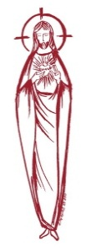
SACRED HEART PARISH

Sacred Heart Parish Founded 1814, The First Catholic Parish in the STate of New Jersey

Sacred Heart Church, 343 South broad Street, Trenton, New Jersey 08608

Holy Cross Church, 233 Adeline Street, Trenton, New Jersey 08611

ALL ARE WELCOME

Whatever your present status in the Catholic Church, whatever your current family or marital situation,

Whatever your past or present religious affiliation, whatever your personal history, age, background, or

race, whatever your own self-image or esteem, you are invited, welcomed, accepted, loved and

respected at the Parish of the Sacred Heart.

PASTOR

Rev. Msgr. Dennis A. Apoldite
frdennis@trentonsacredheart.org
PAROCHIAL VICAR
Rev. Charles Muorah
Felician Residence for Clergy
233 Adeline Street, Trenton, New Jersey 08611
609-393-4826 ext. 108 for Fr Charles

DEACON
Dr. Christian Nnajiofor
Business Manager / ADMINISTRATIVE ASSISTANT
John DeSantis: secretary@trentonsacredheart.org
Administrator of religious education
Mary Tovar: reled@trentonsacredheart.org
COORDINATORS OF SACRED MUSIC
Natalie Megules ~ 609-575-6484
Rupert Peters ~ Gospel Mass 609-442-7871
MAINTENANCE DEPARTMENT
Frank Rios
Trustees
Jack Breuer and Ellieen Ancrum Ingbritsen,

OFFICE HOURS

9:00am – 4:00pm Monday – Friday

SACRED HEART PARISH OFFICE

343 South Broad Street, Trenton, NJ 08608

Phone: (609) 393-2801 ~ Fax: (609) 989-8997

WEB PAGE:

www.trentonsacredheart.org

CEMETERY RECORDS
Contact The Office of Catholic Cemeteries at 609-394-2017 or DirectorofCemeteries@DioceseofTrenton.org

SACRAMENTAL RECORDS
Sacred Heart Church, Saint John’s Church, Saint Francis Church, Saints Peter and Paul Church, Saint Stanislaus Church, Holy Cross Church, Blessed Sacrament Church, Our Lady of Divine Shepherd Church, Blessed Sacrament/Our Lady of Divine Shepherd Parish and Divine Mercy Parish.

Liturgy Schedule

Sacred Heart
Monday, Tuesday, Wednesday and Friday
12:10 Noon
Saturday Evening 5:15 PM
Sunday Morning 9:00 and 11:15 AM
HOLY CROSS
Monday, Thursday and Friday 8:00 AM
Saturday Evening 4:00 PM
Sunday Morning 10:00 AM Gospel
12:00 Noon Polish
For each Holy Day please reference the bulletin

SACRAMENTS
BAPTISM
Please call the Parish Office at least one month in advance.

RECONCILIATION

Every First Friday following the 12:10PM Mass SHC

Saturday afternoon ~ 4:30 to 5:00 PM SHC

Every Saturday from 3:30 to 3:50 PM HCC

Every Sunday 9:30 to 9:50AM HCC

and by appointment.
EUCHARISTIC ADORATION
First Saturday of the Month 2:30 to 3:30 pm
in Holy Cross Church
MARRIAGE
Please call the Parish Priest at least one year in advance to set up initial meeting and to confirm a wedding
date and time.
ANOINTING OF THE SICK
Please call the Priests any time 609-393-2801.
COMMUNION TO THE HOMEBOUND
Call the Parish Office to schedule home visit.
CONSIDERING PRIESTHOOD?
Email: Vocations@DioceseofTrenton.org
Sixteenth Sunday in Ordinary Time
July 23, 2023

MASS INTENTIONS
Saturday, July 22
4:00 pm ~ Shelby Rowe and John and Lena
5:15 pm SHC ~ Johanna Schino
Sunday, July 23
9:00 SHC ~ Harry Gallo
10:00 HCC ~ The intentions of the People of the Parish
11:15 SHC ~ Carol Ann Carabelli
12:00 HCC Polish ~ Maria Bonna
Monday, July 24
8:00 am HCC ~ Special Intention
12:10pm SHC ~ Janet Auletta
Tuesday, July 25
12:10 pm SHC ~ Mr. Donald Bound Sr
Wednesday, July 26
12:10 pm SHC ~ Pat Tagliaferri
Thursday, July 27
8:00 am HCC ~ For Vocations
Friday, July 28
8:00 am HCC ~ For the Sick of the Parish
12:10pm SHC ~ John Matthews
Saturday, July 29
4:00 pm ~ Charlene A. Kuzma
5:15 pm SHC ~ Special Intention
Sunday, July 30
9:00 SHC ~ John Matthews
10:00 HCC ~ Nigerian Christian Mothers Association
11:15 SHC ~ Anella Ferrara and the Miraldo Family
12:00 HCC Polish ~ The intentions of the People of the Parish

OUR SICK LIST
Steve Jurczynski, Trudy Breuer, Cornell Hess, Carole Minotti, Ruby Covington, Judith Santigo, Ching Kukis, Dan Breese Jr, Brenna Kennedy-Moore, Dawn Chia, Mark Friedman, Robert Leighton, Patrick Leighton, Alexander A. Ladnyk, Kelly Nitti, Lauren Clayton, Joseph Edralin, Margie Tiongson, Kevin, Vincent Cooper, Jr., Gail Ladnyk, Leo Genovesi, Sloane Donnelly, Richard Buckley, Tony Ragolia, Barbara Burrows, Robert Mahon, Charles Burrows, Dorothy Amoroso, Maryann Sullivan, Regina Friedman, Rita Mich, Stanley Winowicz, Greg Schafer, Jack Hardiman, Paul Leighton, Amy Birk, Julia Grazioli, Matt and Leona Tydryszewski.

OUR DECEASED

Rita Woods, Geraldine Mangini, and our friends at South Village, Riverside Nursing and Rehabilitation Center, Mill House and Waters Edge.

MINISTRY SCHEDULE
(subject to change)
Saturday, July 22
4:00pm HCC ~ Fr Charles L. V Zielinski Em. M Herpel
5:15pm MsgrDennis L. R Hernandez Em. W Lewis, M. Salamandra
Sunday, July 23
9:00 SHC ~ Msgr. Dennis L. A Urbaniak, Em A Green W James
10:00 HCC ~ Fr. Charles L. O Nnadi Em K Mich
11:15 SHC ~ Msgr. Dennis L. M Tovar Em K Myers T Rizzuto
12:00 HCC Polish ~ Fr Charles

Saturday, July 29
4:00pm HCC ~ Fr Charles L. C Benitez Em. A Lennon
5:15pm Msgr. Dennis L. L Seabrook Em. J Breuer. B DuMont
Sunday, July 30
9:00 SHC ~ Msgr. Dennis L.K Valentino, Em K F & E Zielinski
10:00 HCC ~ Fr. Charles l. R Nnajiofor, Em G Mowenn
11:15 SHC ~ Msgr. Dennis L. M Rogers Em K Parasimo A Woloff
12:00 HCC Polish ~ Fr Marian

WEEKLY COLLECTION
Last weekend’s collection amounted to $7,199.00.. This includes the donations received in Church and the mail ins. Thank you for your continued support of our parish.

2023 ANNUAL CATHOLIC APPEAL UPDATE
Goal: $33,000.00 : Pledged: $43,881.00 (133% of Goal)

READINGS FOR THE WEEK
Sixteenth Week in Ordinary Time
Sunday Wis 12:13, 16-19; Rom 8:26-27; Mt 13:24-43
Monday Ex 14:5-18; Mt 12:38-42
Tuesday 2 Cor 4:7-15; Mt 20:20-28
Wednesday Ex 16:1-5, 9-15; Mt 13:1-9
Thursday Ex 19:1-2, 9-11, 16-20b; Mt 13:10-17
Friday Ex 20:1-17; Mt 13:18-23
Saturday Ex 24:3-8; Jn 11:19-27 or Lk 10:38-42

PROMISE TO PROTECT
The Diocese of Trenton is committed to the norms of the U.S. Bishop’s Charter for the Protection of Children and Young People in regard to the reporting and investigation of sexual abuse allegations involving minors. If you have been sexually abused as a minor by anyone representing the Catholic Church, you can report that abuse through the diocesan Hotline: 1-888-296-2965 or via e-mail at abuseline@dioceseoftrenton.org. Allegations are reported to the appropriate law enforcement agencies.

Collection scheduled for retired, elderly and infirm priests fund
Bishop David M. O’Connell, C.M., is again inviting parishioners in the Diocese of Trenton to support the second annual collection for the Retired, Elderly and Infirm Priests Fund scheduled for Masses July 22 and 23. The collection is part of the diocesan observance of World Day for Grandparents and the Elderly -- established three years ago by Pope Francis to be held on or near the Feast of Jesus’ own grandparents, Saints Joachim and Anne. The collection, which will be taken in all Catholic churches across Burlington, Mercer, Monmouth and Ocean Counties, will be used to help fund the needs of the retired and elderly priests of the Diocese whose numbers have now reached 85.
In announcing this year’s collection, Bishop O’Connell stated, “As we celebrate the feast of
the grandparents of Jesus, I am also mindful of the priests of the Diocese who have ‘born the heat of the day’ in our parishes and institutions, serving and ministering to us and who are now retired. They are truly our ‘spiritual grandparents’. Many continue to offer Masses and share the Sacraments in our parishes.
“As Bishop, I invite all the clergy and faithful of the Diocese, once again, to show the generosity for which I have come to know you so well by contributing to the annual collection for the retired, elderly and infirm priests of the Diocese. They, too, deserve our love and gratitude in their twilight years!”

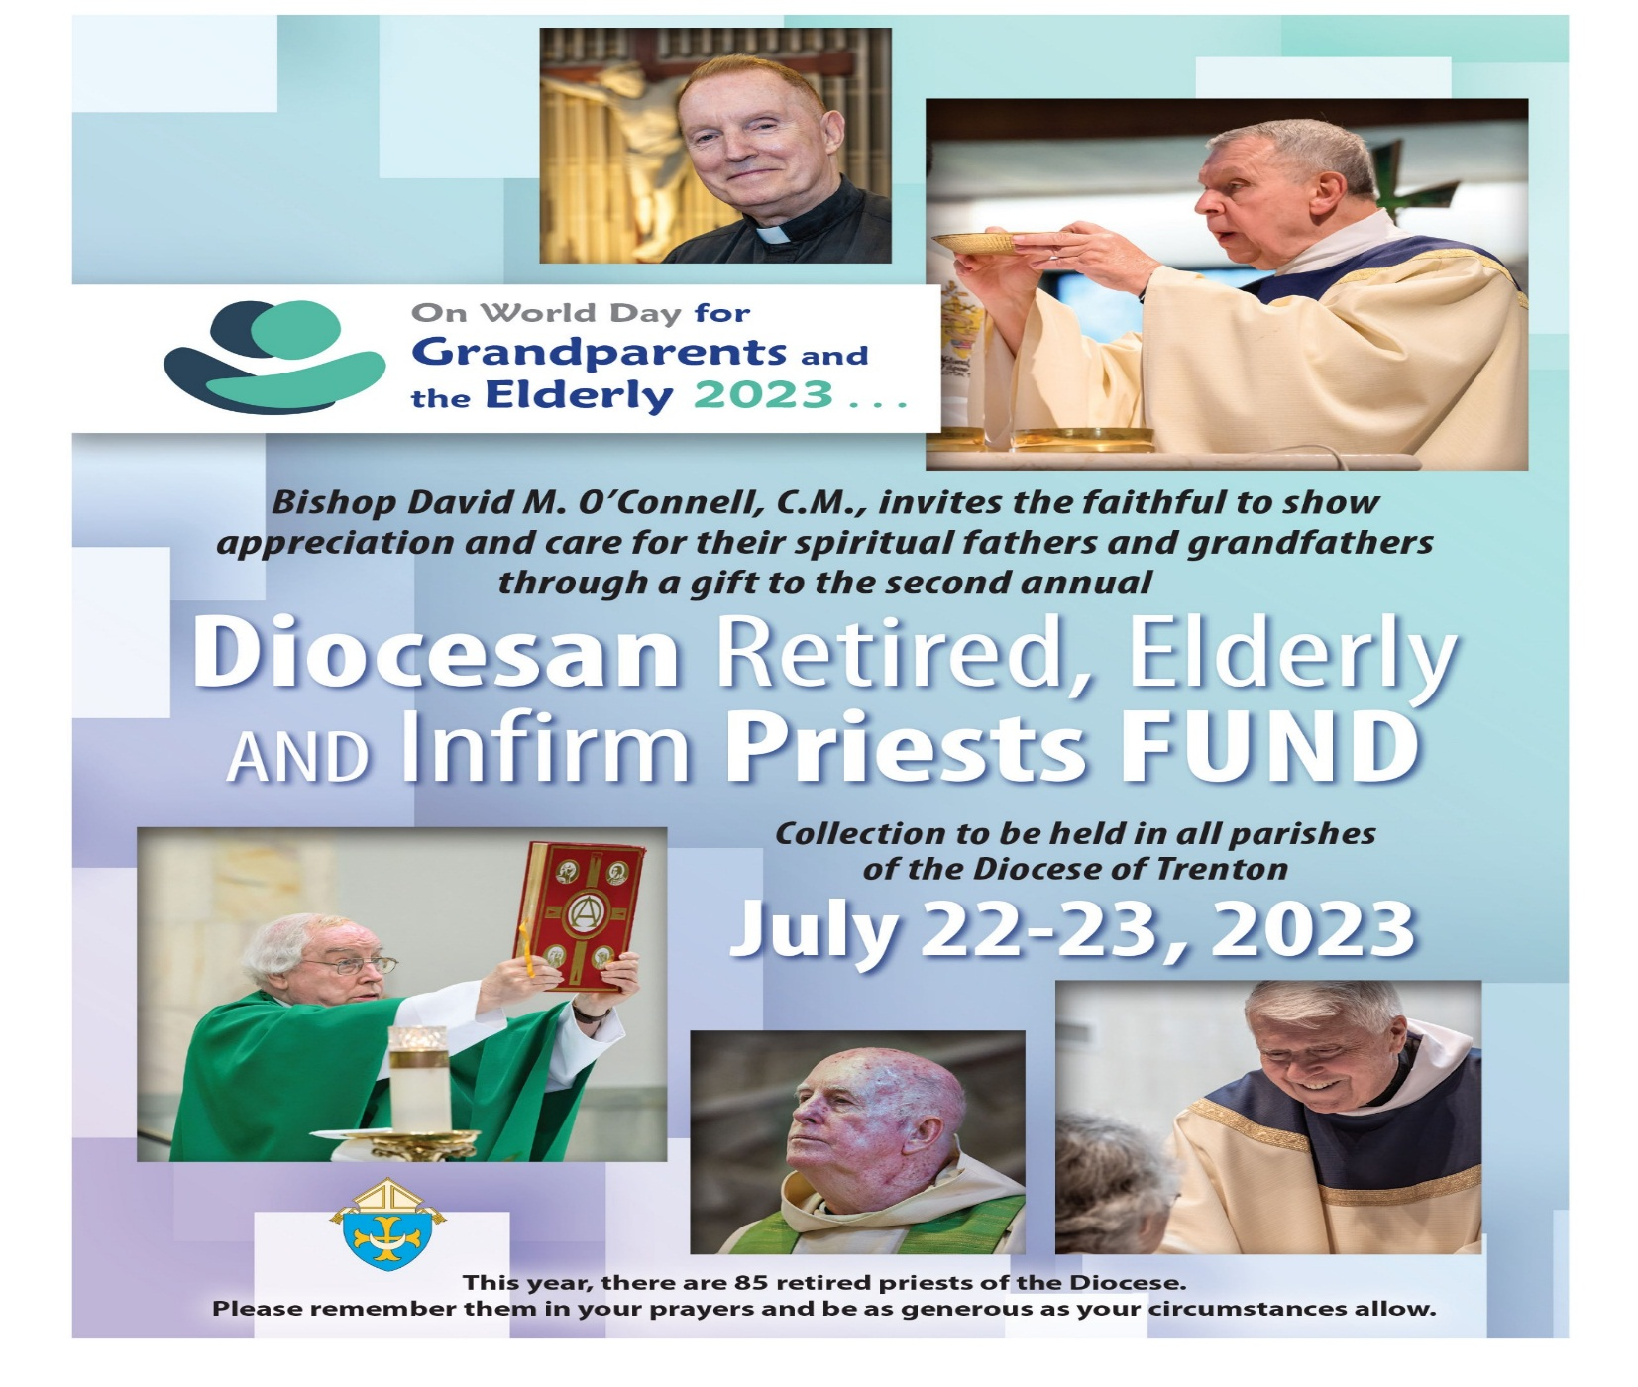
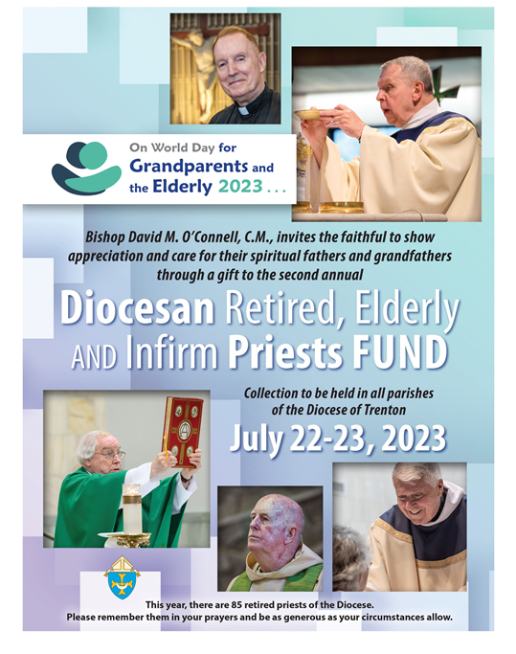

NIGERIAN CHRISTIAN MOTHER’S ASSOCIATION
Next weekend the Nigerian Christian Mother’s Association will celebrate their Inauguration Day Mass at 10:00am in Holy Cross Church. All are welcome to attend.

SCHOOL SUPPLY COLLECTION
This year we will be collecting school supplies for the children in our neighborhood who are in need of assistance. Please bring your gifts to the altar on the weekend of August 12th & 13th. All school supplies from back packs to pencils are acceptable. Thank you.

RCIA – BECOMING CATHOLIC
Are you interested in becoming a Catholic? The desire to draw closer to God is in all of us, for we are his creation. Do you know an adult who would like to find out about what we believe? Do you know anyone who has not completed the Sacraments of Communion and Confirmation, and would like to? Please prayerfully consider who might be interested in entering more fully into the Catholic faith and invite them to join us for our “Inquiry session” scheduled to begin in September. Please contact Msgr. Dennis at
Frdennis@trentonsacredheart.org or
609-393-2801 ext. 102..

NOW IS THE TIME TO REGISTER
YOUR CHILDREN FOR RELIGIOUS EDUCATION
Parents are asked to reregister their children on or before the last class. New Registration and Re-registration forms are available online or at the Parish Office. The tuition fee is $65.00 per child.

COMMUNION AND CONFIRMATION CLASS
If you have a child who is ready to make his or her First Communion or Confirmation, the Diocesan guideline requirement is that they complete two years of Religious Education prior to receiving the Sacraments.

WEDDING ANNIVERSARY BLESSING
The Department of Evangelization and Family Life is pleased to announce the 2023 Bishop’s Anniversary Blessing for all couples celebrating a milestone anniversary of their Catholic Marriage. All couples celebrating their 1st, 25th or 50th (or more) anniversary in the 2023 calendar year are invited to attend. Anniversary couples must be validly married in the Catholic Church and registered members of a parish in the Diocese of Trenton. The Bishop’s Anniversary Blessing Mass for Mercer and Burlington County Parishes will be held on Sunday, October 22, 2023 at 3 pm in the Cathedral of St. Mary in Trenton. General information about the 2023 Bishop’s Anniversary Blessing events including online registration for anniversary couples can be found at www.dioceseoftrenton.org/bishops-anniversary-blessing.

RETROUVAILLE
Tens of thousands of couples have healed their marriages through Retrouvaille (pronounced Retro-vy). Couples learn to build communication skills and to increase intimacy. It provides help for marriage problems, difficulties or crises. The Office of Family Life, Diocese of Metuchen, will sponsor a Retrouvaille weekend on August 18-20. For further information, please contact Rich Colasuonno (732-236-0671) or Annette Colasuonno (732-672-0748) or email 3024@helpourmarriage.org. The Family Life Center in Malvern, PA will hold Retrouvaille weekends on August 18 - 20 and October 6 – 8. For more information, or to register, visit www.HelpOurMarriage.org or call 215-766-3944 or 800-470-2230. All inquiries are strictly confidential.

NEW STATUE IN SACRED HEART CHURCH
We ae grateful to the family of Joanne Perrone, a long time friend of Sacred Heart Parish, for the donation of the statue of Saint Aloysius Gonzaga. Aloysius was an Italian who became a member of the Society of Jesus. While still a student at the Roman College, he died at the age of 23, as a result of caring for the victims of a serious epidemic. His feast day is June 21st and he is the patron of youth.
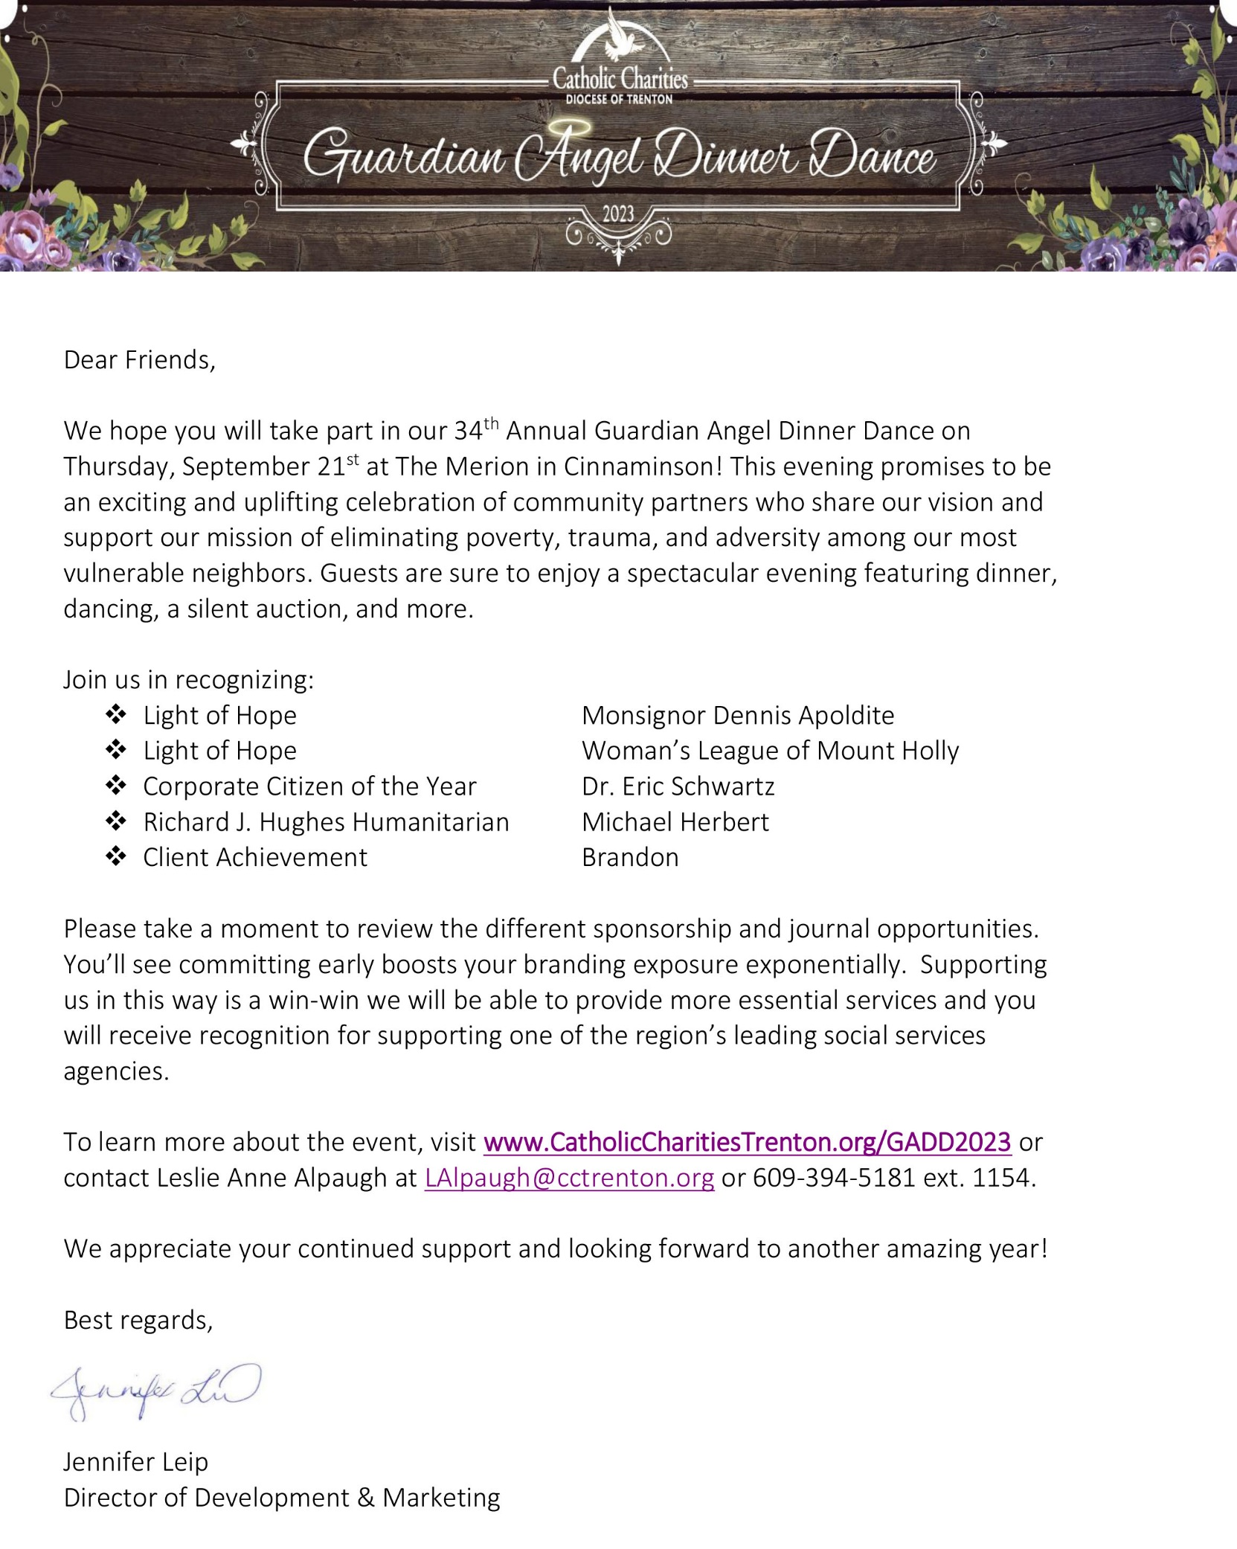

SHOW YOUR SUPPORT
We are excited to announce that Msgr. Dennis Apoldite is being honored as one of Catholic Charities Light of Hope honorees at their 2023 Guardian Angel Dinner Dance. Please show your support in honoring Msgr. Dennis by donating to Catholic Charities through the purchase of an ad, dinner ticket, or journal opportunities. More information is available by going to the links listed in the letter above.
Catholic Charities staff will be with us in a few weeks to offer you the opportunity to purchase 50/50 tickets for their organization. Donations can be made in any amount, payable to Catholic Charities, Diocese of Trenton P.O. Box 1423, Trenton NJ 08607

PRAYER FOR THE THIRD WORLD DAY FOR GRANDPARENTS AND THE ELDERLY 2023
Virgin Mary, Mother of faith and hope, an example for this humanity bent by indifference, make me as willing as You to accept the will of God, to magnify and praise His Mercy. Mary, Mother of fortitude, you who knows my heart, do not allow me to become discouraged. I confidently surrender my life into your hands. Heal my wounds. May your tenderness accompany me on the way. Your presence, Mother of love, brings us to experience the joy of seeing our families united. Help me to transmit the tenderness and Love of God to the grandchildren and youth so that, in addition to praying for them, we can pray with them. Mary, may the gift of the Holy Spirit intercede for me: sustain my weakness; breathe into my heart the consolation that I may leave traces of faith among the young, bearing witness to the beauty of life, knowing that life has a limit and that beyond it lies before us our Father's embrace. Amen

EXCERPTS FROM THE MESSAGE OF HIS HOLINESS POPE FRANCIS
Dear brothers and sisters!
“His mercy is from age to age” (Lk 1:50). This is the theme of the Third World Day for Grandparents and the Elderly, and it takes us back to the joyful meeting between the young Mary and her elderly relative Elizabeth (cf. Lk 1:39-56). Filled with the Holy Spirit, Elizabeth addressed the Mother of God with words that, millennia later, continue to echo in our daily prayer: “Blessed are you among women and blessed is the fruit of your womb” (v. 42). The Holy Spirit, who had earlier descended upon Mary, prompted her to respond with the Magnificat, in which she proclaimed that the Lord’s mercy is from generation to generation. That same Spirit blesses and accompanies every fruitful encounter between different generations: between grandparents and grandchildren, between young and old. God wants young people to bring joy to the hearts of the elderly, as Mary did to Elizabeth, and gain wisdom from their experiences. Yet, above all, the Lord wants us not to abandon the elderly or to push them to the margins of life, as tragically happens all too often in our time………
………………. The World Day for Grandparents and the Elderly is meant to be a small but precious sign of hope for them and for the whole Church. I renew my invitation to everyone – dioceses, parishes, associations and communities – to celebrate this Day and to make it the occasion of a joyful and renewed encounter between young and old. To you, the young who are preparing to meet in Lisbon or to celebrate World Youth Day in your own countries, I would ask: before you set out on your journey, visit your grandparents or an elderly person who lives alone! Their prayers will protect you and you will carry in your heart the blessing of that encounter. I ask you, the elderly among us, to accompany by your prayers the young people about to celebrate World Youth Day. Those young people are God’s answer to your prayers, the fruits of all that you have sown, the sign that God does not abandon his people, but always rejuvenates them with the creativity of the Holy Spirit.
Dear grandparents, dear elderly brothers and sisters, may the blessing of the embrace between Mary and Elizabeth come upon you and fill your hearts with peace. With great affection, I give you my blessing. And I ask you, please, to pray for me.
FRANCIS

